In Elastic Agent (Fleet) database integrations like MySQL, Oracle, PostgreSQL, MSSQL, MongoDB, etc., the focus is database observability + performance + errors, not just logs.
Below is a clean, practical list of what these DB integrations can do 👇

1️ Query & Performance Monitoring (APM-style for DBs)
What you get
- Slow queries
- Long-running queries
- Query execution time
- Queries waiting on locks
- Queries causing high CPU / IO
Examples
- Query taking > 5 seconds
- Repeated SELECTs causing load
- Queries blocked due to table locks
- Sudden spike in query latency
📌 Used for performance tuning & root cause analysis

2️ Error & Failure Monitoring
Captured
- Query execution errors
- Syntax errors
- Permission / access denied errors
- Connection failures
- Deadlocks
- Transaction rollbacks
Examples
- ORA-00060: deadlock detected
- Too many connections
- Table does not exist
- Authentication failures
📌 Used for alerting & troubleshooting

3️ Connection & Session Monitoring
What is tracked
- Active connections
- Idle connections
- Connection spikes
- Max connections usage
- Session states
Examples
- App leaking DB connections
- Sudden connection surge after deployment
- DB hitting connection limit
📌 Very useful for production incidents

4️ Resource Usage Metrics (DB Health)
Metrics collected
- CPU usage
- Memory usage
- Disk IO
- Read/write latency
- Buffer cache hit ratio
- Temporary space usage
Examples
- High disk IO → slow queries
- Memory pressure → cache misses
- CPU saturation during peak load
📌 Helps capacity planning

5️ Locking, Blocking & Deadlocks
Monitored
- Table locks
- Row locks
- Blocking sessions
- Deadlocks
Examples
- Transaction A blocking Transaction B
- Long-running UPDATE locking table
- Deadlock between two services
📌 Critical for high-concurrency systems

6️ Replication & High Availability (where supported)
What you see
- Replication lag
- Replica status
- Primary vs replica health
- Sync failures
Examples
- Replica lag increasing
- Read replicas falling behind
- Replication stopped
📌 Important for read-heavy architectures

7️ Transaction Monitoring
Collected
- Commit / rollback counts
- Long-running transactions
- Failed transactions
Examples
- Transaction open for 30+ minutes
- Frequent rollbacks indicating app issue

8️ Database Logs (Optional but Powerful)
Log types
- Error logs
- Slow query logs
- Audit logs
- General logs (optional)
Examples
- Unauthorized access attempts
- Schema change logs
- Admin operations
📌 Works best when logs + metrics are combined

9 Built-in Dashboards (Out of the box)
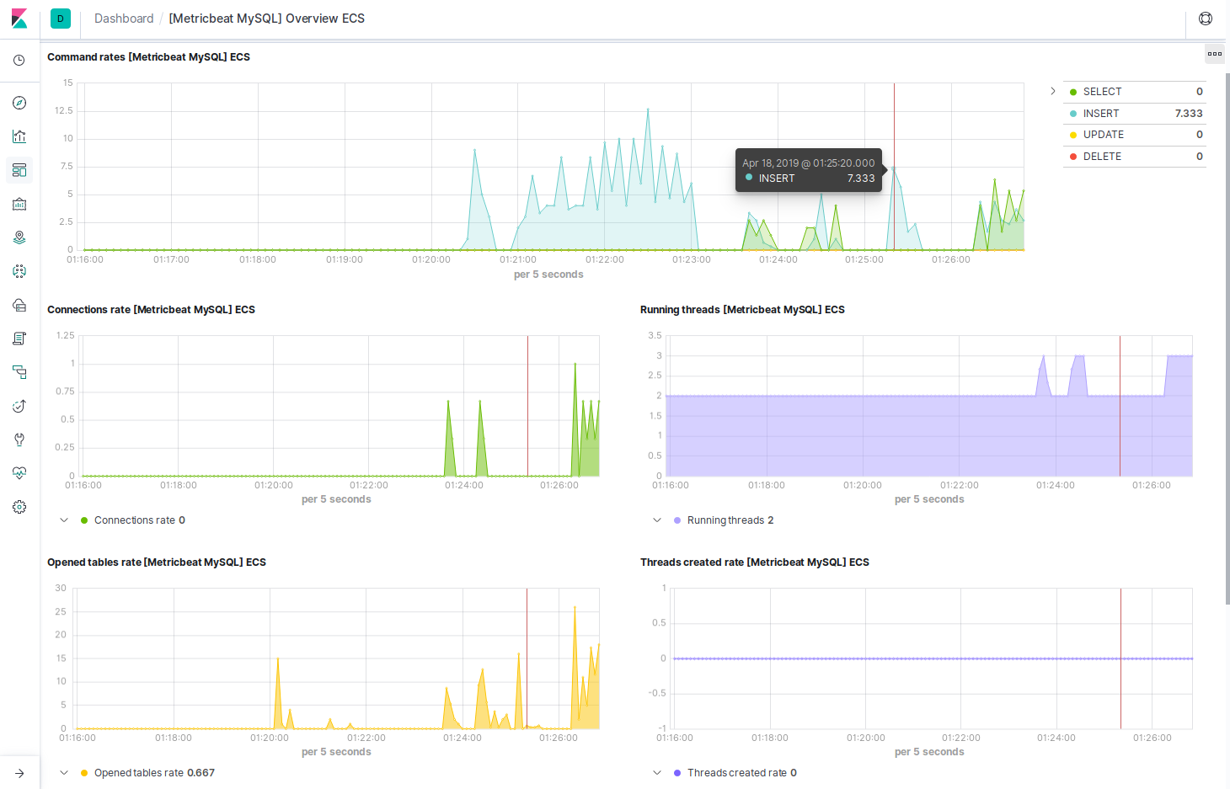
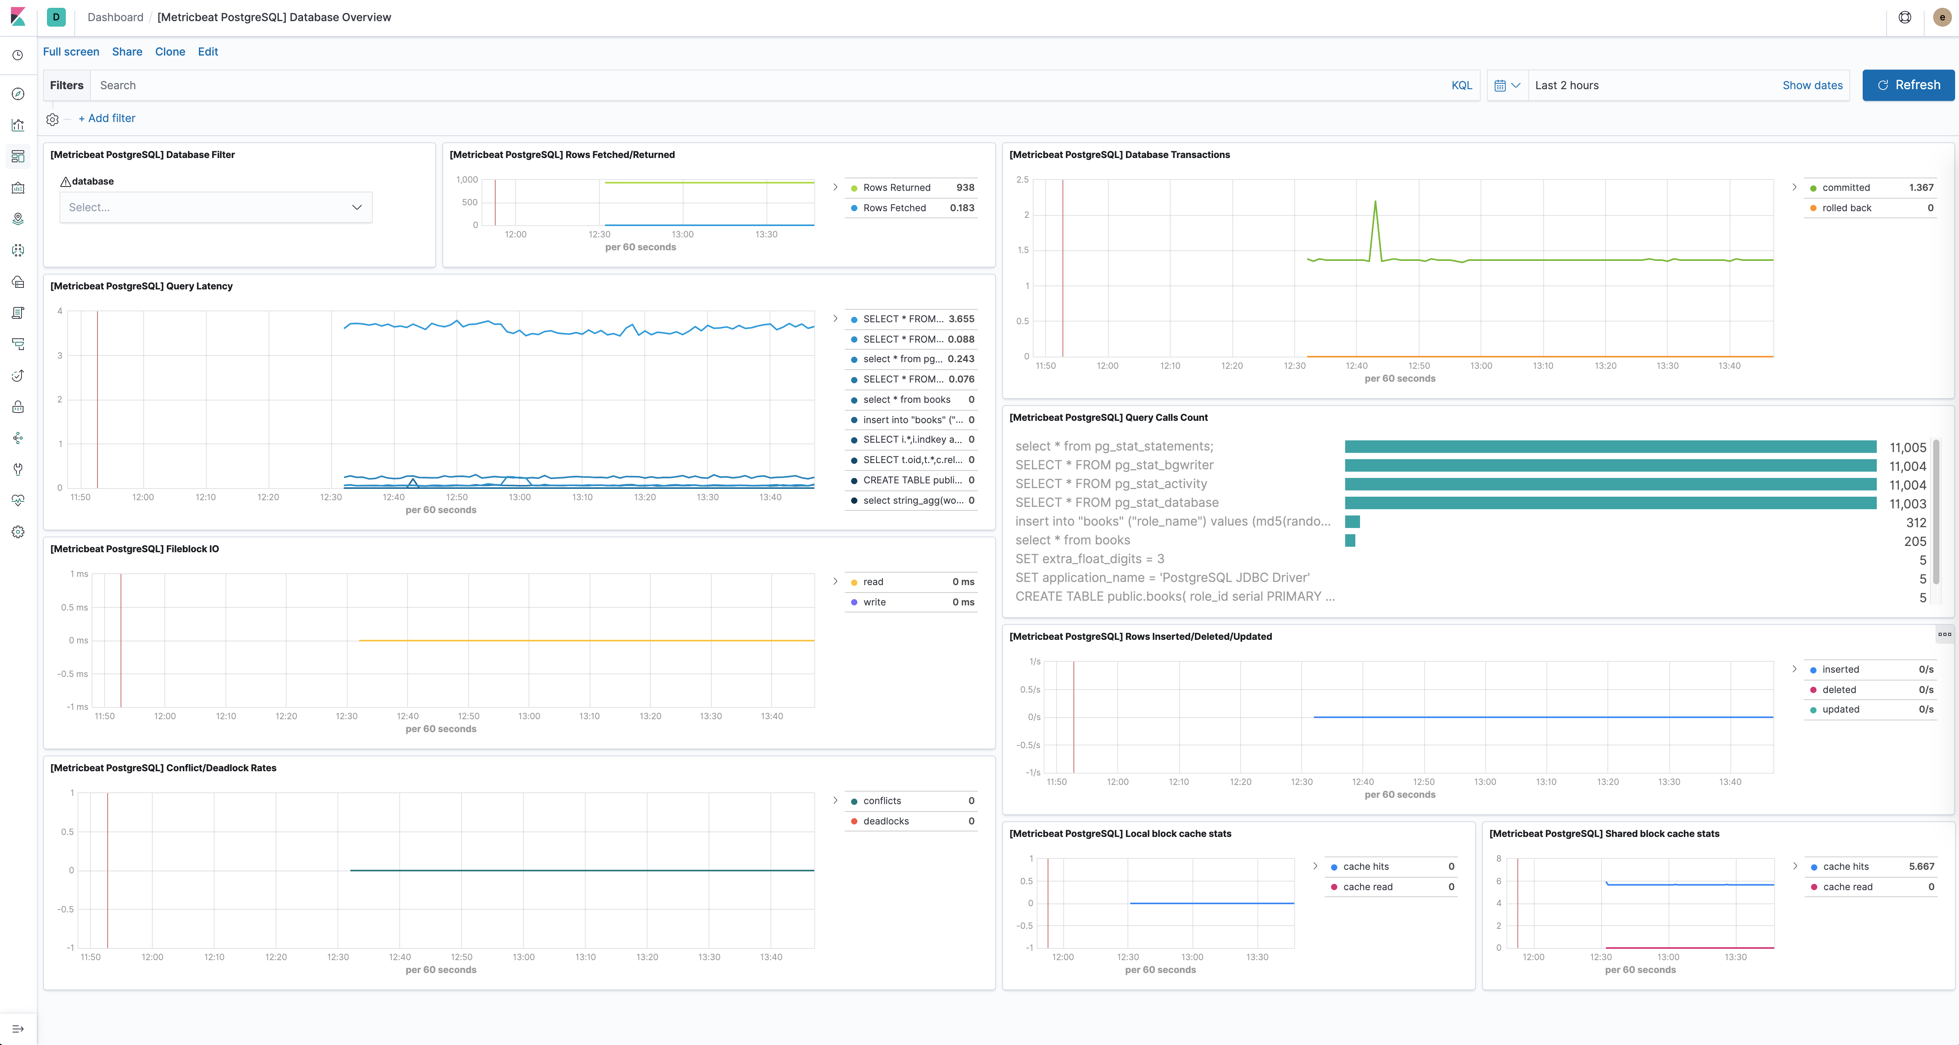
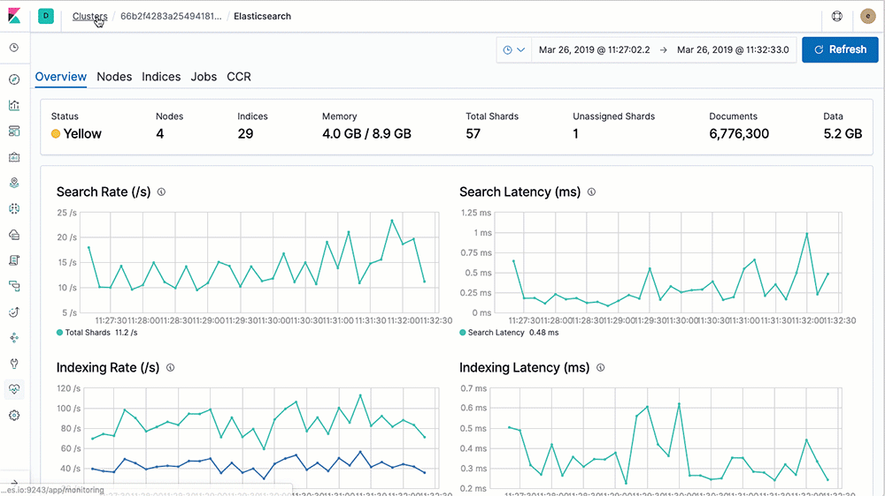
You get ready-made dashboards like:
- DB Overview
- Query latency
- Errors & failures
- Connections
- Resource usage
No manual visualization needed 🚀

10️ Alerting Use Cases (Very Common)
You can create alerts like:
- Slow query > 5s
- Error count > X
- Connection usage > 80%
- Deadlock detected
- Replication lag > threshold
- CPU > 90% for 5 mins
📌 These alerts integrate directly with Kibana Rules

🔹 Summary (One-Line View)
Area | What It Covers
Performance | Slow queries, latency
Stability | Errors, crashes
Capacity | CPU, memory, IO
Concurrency | Locks, deadlocks
Availability | Replication health
Security | Auth failures, audit logs

If you want, next I can:
- Map which DB supports which feature
- Explain difference between DB integration vs APM
- Give real production alert examples
- Explain how Fleet DB monitoring works internally
Just tell me 👍

